Registering your 8th grade student on Parent Portal
To Register on ParentPortal, sign in as normal. On the left, look for “Class Registration”
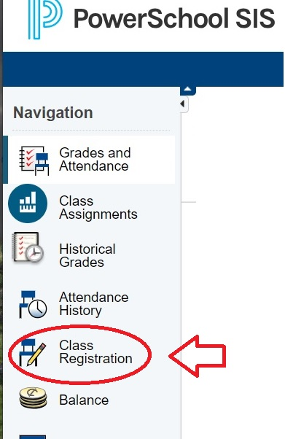
Beside each subject, click the pencil icon for courses available.
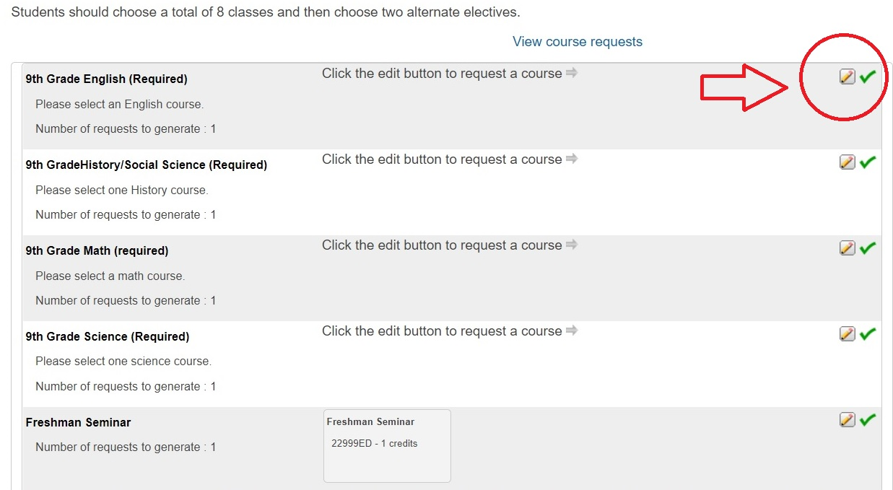
Select the course you want to take by checking the box. Courses with “AD” at the end are Advanced. Courses with “HO” at the end are Honors.
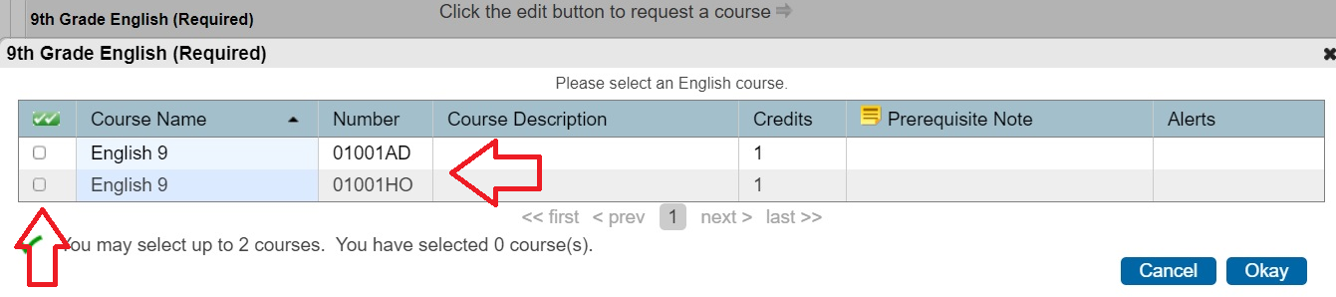
Repeat this process for all core subjects. Make sure you hit “OK” each time and the class you have selected will appear in the text box.
Freshman Seminar is already pre-populated as it is a required class.
After these first 5 courses, you will be able to repeat these steps for World Languages, Electives, and Alternative Electives.

